Breanna Gorham
Natasha Foreman
Garrett Rhodes

Milestone #1
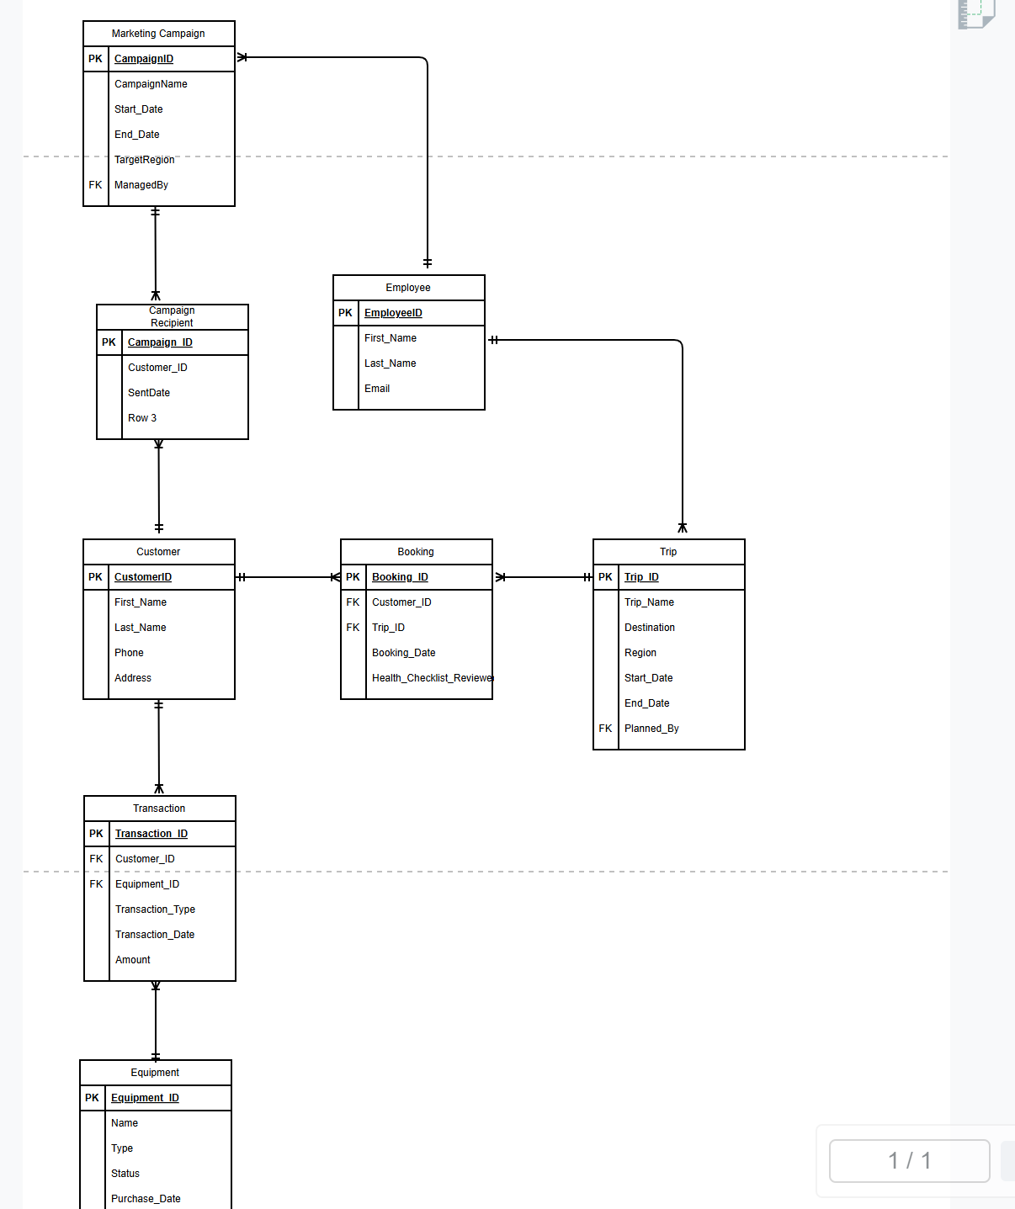

Business Rules :
- A Customer can book many Trips via the Booking
- A Trip can have many Customers via Booking
- A Trip is planned by one Guide
  - (FK to Employee table)
- An Employee can plan many Trips
- A Customer can make many Transactions
  - (rent/sell Equipment)
- Each Equipment item can only have one status at a time
- One Employee manages the Equipment
- A Marketing Campaign can be sent to many Customers
- A Customer can receive many Campaigns
- A Customer can rent/buy many Equipment items via a Transaction

